UniLogic — DR Visual Conflict Reference
Each diagram shows one setting value and every other value it conflicts with, across all settings.

How to read these diagrams: the source value is on the left. Each line connects it to a value it conflicts with — in any setting, not just its own group. A solid red line means the two values must never appear on opposite sides of a cross-file call. A dashed amber line means they can coexist with care, but there are documented traps.

Memory Management

memory = gc
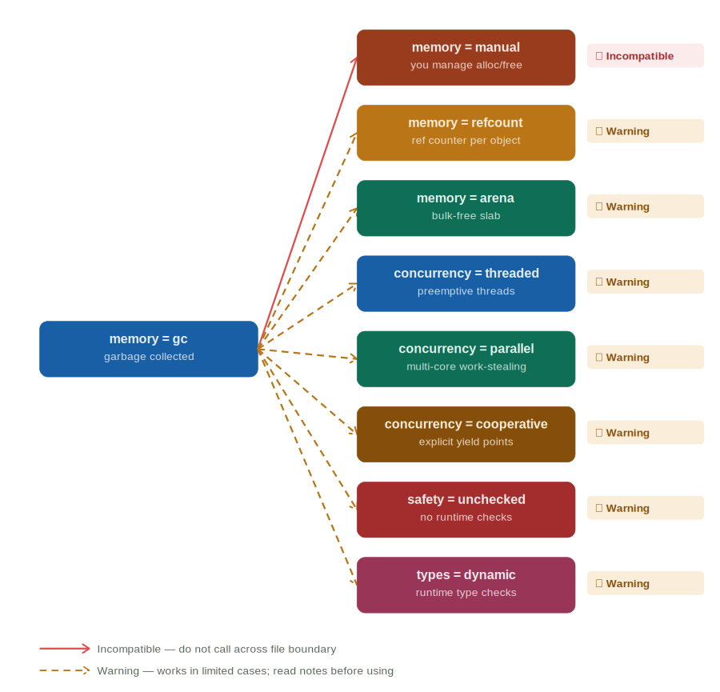
Conflicts with | Severity | What happens
memory = manual | ✗ Incompatible | GC frees object; manual code holds dangling pointer → crash or silent corruption
memory = refcount | ⚠ Warning | GC may collect before refcount reaches 0; use explicit bridges between files
memory = arena | ⚠ Warning | Arena freed at end of scope; GC objects may outlive arena-owned data
concurrency = threaded | ⚠ Warning | GC stop-the-world pauses block all threads; mutexes and timing behave unpredictably during collection
concurrency = parallel | ⚠ Warning | Parallel workers stall mid-task during GC pause with no warning or coordination
concurrency = cooperative | ⚠ Warning | GC may interrupt between yield points; whether this breaks depends on the GC implementation — compiler cannot guarantee safety
safety = unchecked | ⚠ Warning | GC normally catches use-after-free; unchecked removes that net — missed pointer becomes silent corruption
types = dynamic | ⚠ Warning | Dynamic types generate more short-lived heap objects, increasing GC pressure and collection frequency

memory = manual
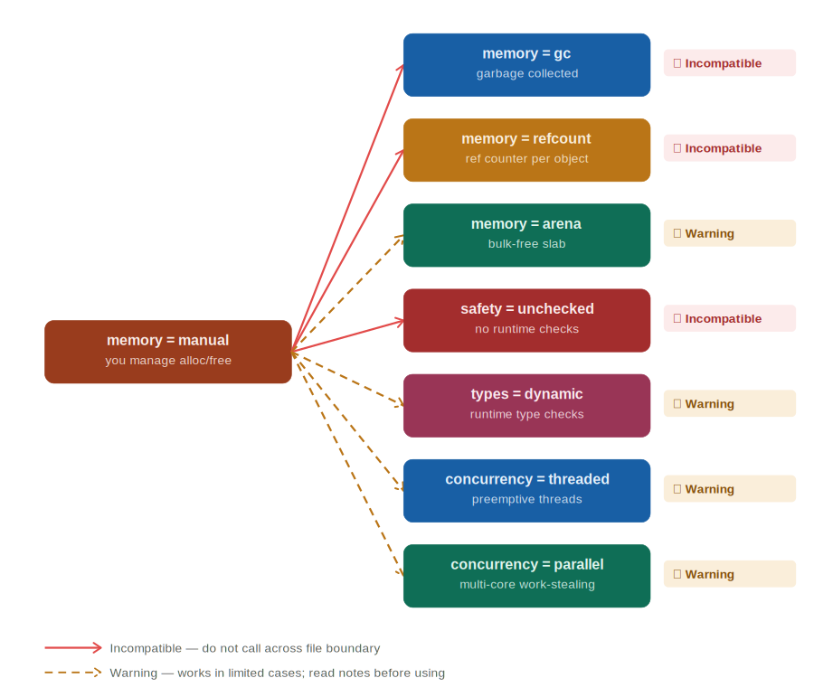
Conflicts with | Severity | What happens
memory = gc | ✗ Incompatible | Manual free + GC collect same object → double-free, heap corruption
memory = refcount | ✗ Incompatible | Both systems attempt to free the same allocation → double-free
memory = arena | ⚠ Warning | Manual code may free arena-owned memory before the arena scope ends
safety = unchecked | ✗ Incompatible | Manual memory with no bounds checking: buffer overflows and use-after-free with zero detection — the classic exploit recipe
types = dynamic | ⚠ Warning | Dynamic typing obscures object lifetimes; hard to know when it is safe to free an object
concurrency = threaded | ⚠ Warning | Manual free from one thread while another thread reads same address; classic heap data race
concurrency = parallel | ⚠ Warning | Parallel workers may all touch the same allocation; free from one worker corrupts others

memory = refcount
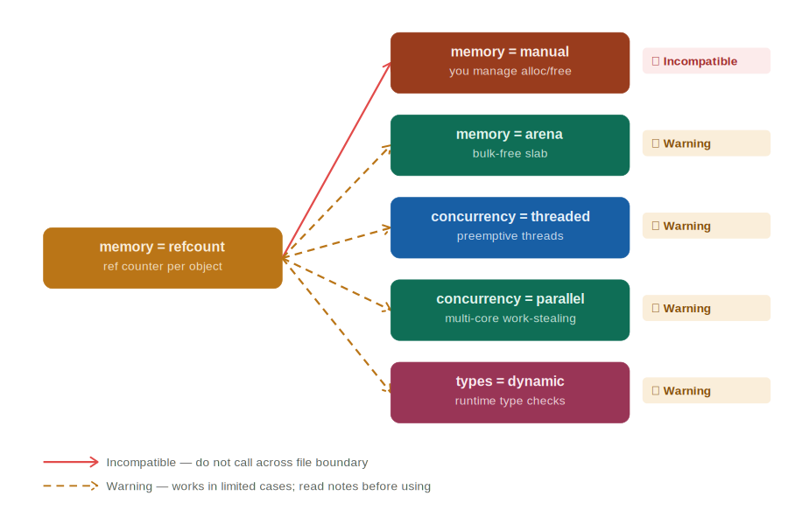
Conflicts with | Severity | What happens
memory = manual | ✗ Incompatible | Refcount hits 0, memory freed; manual code still holds a pointer → use-after-free
memory = arena | ⚠ Warning | Arena bulk-freed while refcount > 0; dangling pointer into freed slab
concurrency = threaded | ⚠ Warning | Counter increment/decrement from multiple threads requires atomics; non-atomic refcount + threads = counter corruption
concurrency = parallel | ⚠ Warning | Same as threaded; parallel workers race on the counter without atomic operations
types = dynamic | ⚠ Warning | Dynamic types make accidental circular references easy; refcount can never free a cycle

memory = arena
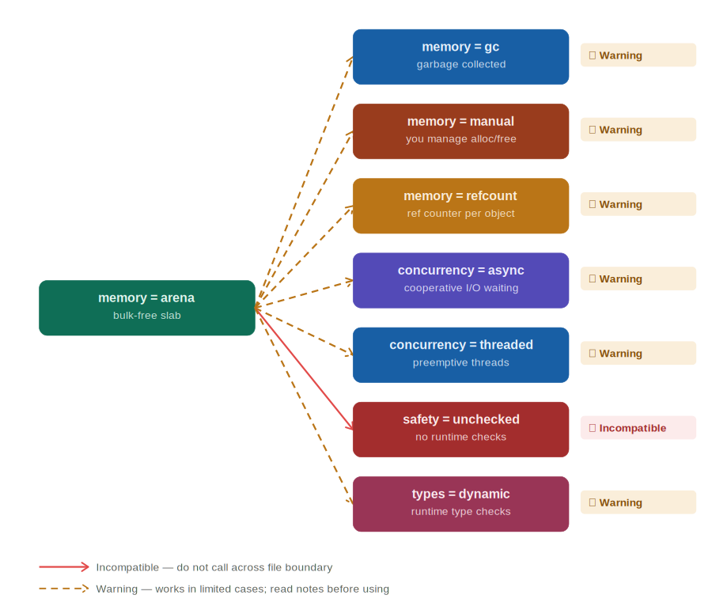
Conflicts with | Severity | What happens
memory = gc | ⚠ Warning | GC allocations inside arena scope; lifetimes don't align with bulk-free
memory = manual | ⚠ Warning | Arena bulk-free pulls out memory manual code still holds
memory = refcount | ⚠ Warning | Arena outlasts refcount object; refcount freed data still accessible via arena pointer
concurrency = async | ⚠ Warning | Async tasks may outlive the arena scope; callback fires after arena is freed → garbage read
concurrency = threaded | ⚠ Warning | Arena is not thread-safe; concurrent allocations from multiple threads corrupt the slab pointer
safety = unchecked | ✗ Incompatible | Arena overflow writes past slab boundary silently; overwrites adjacent memory with no error raised
types = dynamic | ⚠ Warning | Dynamic types have variable sizes that can fragment or overflow the arena unpredictably

Safety Checking

safety = checked
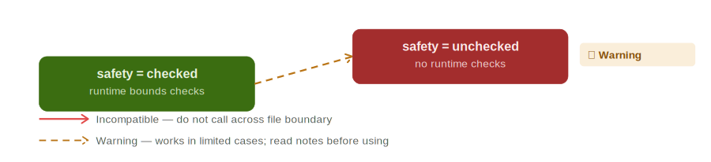
Conflicts with | Severity | What happens
safety = unchecked | ⚠ Warning | Checked code calls unchecked; errors in callee are invisible to caller's safety net

safety = unchecked
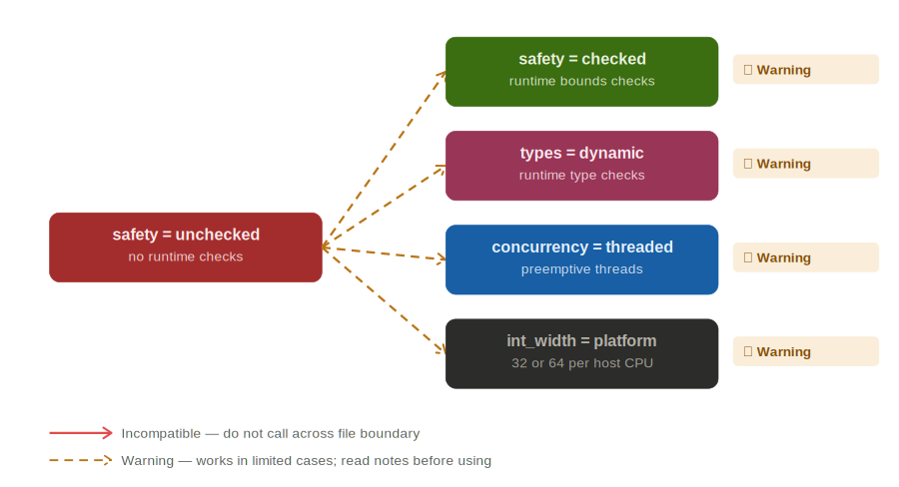
Conflicts with | Severity | What happens
safety = checked | ⚠ Warning | Unchecked code may pass corrupted state into checked callee; error surfaces far from source
types = dynamic | ⚠ Warning | Type mismatches that checked mode catches at runtime become silent wrong reads
concurrency = threaded | ⚠ Warning | Data races that checked mode surfaces become invisible; wrong values with no error
int_width = platform | ⚠ Warning | Platform-width overflow is already hard to reason about; removing overflow detection makes it invisible

Type System

types = strict
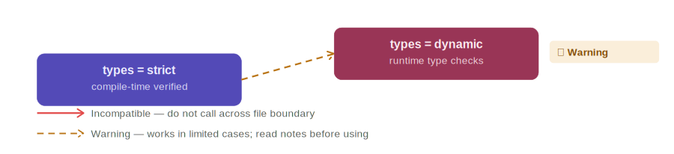
Conflicts with | Severity | What happens
types = dynamic | ⚠ Warning | Strict caller receives dynamic return value; type mismatch not caught until runtime

types = dynamic
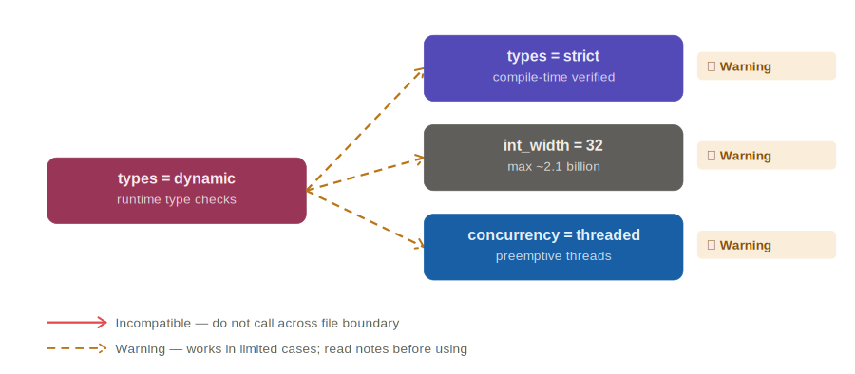
Conflicts with | Severity | What happens
types = strict | ⚠ Warning | Dynamic code passes wrong type into strict callee; crash at call boundary
int_width = 32 | ⚠ Warning | Dynamic code passing large numbers into 32-bit slots silently truncates — already in matrix, shown here for completeness
concurrency = threaded | ⚠ Warning | Type of a shared variable can change between threads; one thread sees int, another sees string, neither errors

Integer Width

int_width = 32
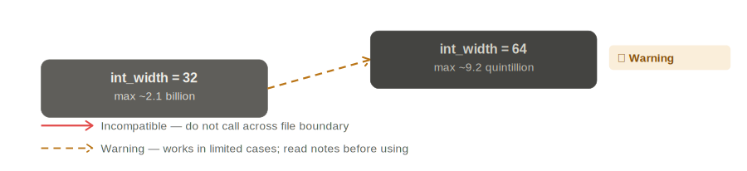
Conflicts with | Severity | What happens
int_width = 64 | ⚠ Warning | 32-bit value promoted to 64-bit; generally safe but sign-extension can corrupt negatives

int_width = 64
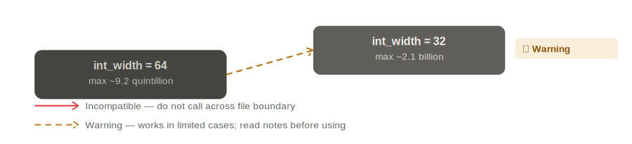
Conflicts with | Severity | What happens
int_width = 32 | ⚠ Warning | 64-bit value passed to 32-bit slot; upper 4 bytes silently discarded → wrong result

int_width = platform
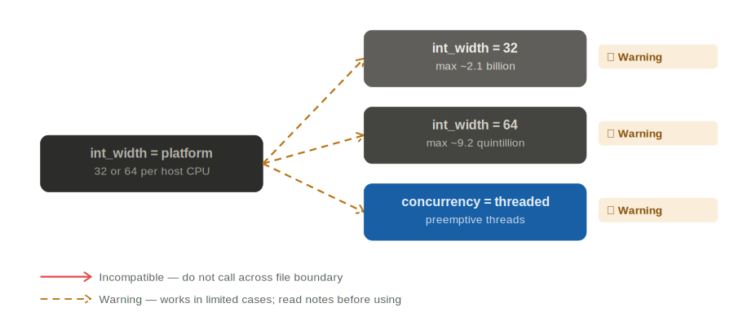
Conflicts with | Severity | What happens
int_width = 32 | ⚠ Warning | Platform=64 on dev machine, 32 in production; overflow on deploy with no dev-side warning
int_width = 64 | ⚠ Warning | Platform=32 on embedded target; 64-bit callee sees truncated values
concurrency = threaded | ⚠ Warning | Even checked mode cannot protect against platform-width race conditions on 32-bit vs 64-bit systems

Concurrency Model

concurrency = threaded
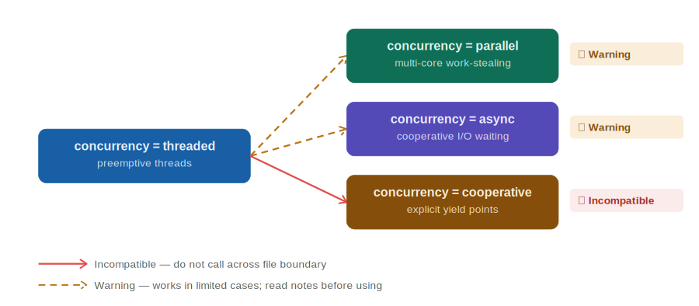
Conflicts with | Severity | What happens
concurrency = parallel | ⚠ Warning | Thread scheduler and parallel work-stealer compete; timing-sensitive code may misbehave
concurrency = async | ⚠ Warning | Async callbacks invoked from wrong thread context; data race possible
concurrency = cooperative | ✗ Incompatible | Preemptive thread interrupts cooperative scheduler mid-yield; invariants broken

concurrency = parallel
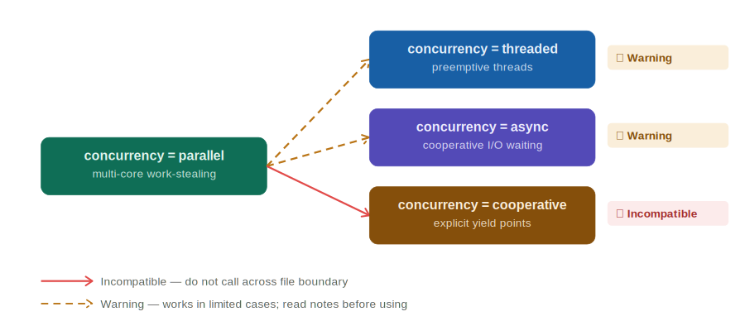
Conflicts with | Severity | What happens
concurrency = threaded | ⚠ Warning | Parallel workers preempt; thread-local state assumptions may not hold
concurrency = async | ⚠ Warning | Parallel dispatch fires async callbacks on arbitrary workers; ordering undefined
concurrency = cooperative | ✗ Incompatible | Work-stealing never yields; cooperative scheduler starved permanently

concurrency = async
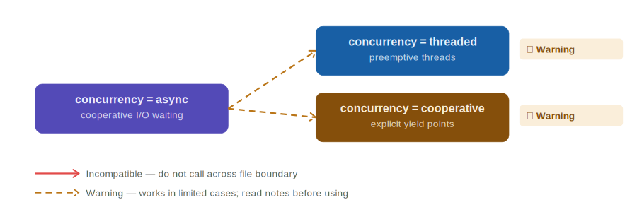
Conflicts with | Severity | What happens
concurrency = threaded | ⚠ Warning | Async resumes on unpredictable thread; shared state needs explicit synchronization
concurrency = cooperative | ⚠ Warning | Async I/O completion may resume inside cooperative turn; yield point semantics unclear

concurrency = cooperative
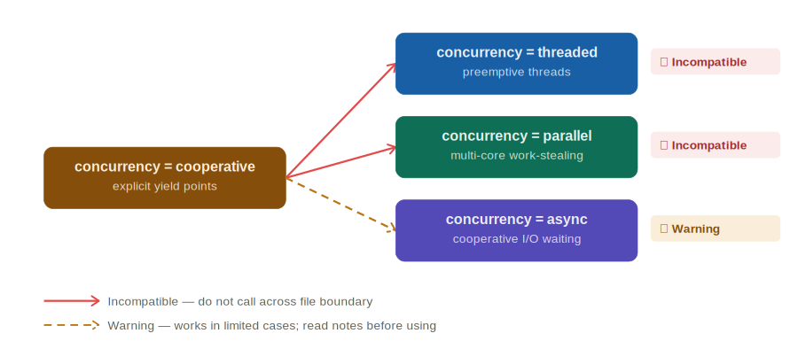
Conflicts with | Severity | What happens
concurrency = threaded | ✗ Incompatible | Cooperative code never yields to thread preemptor; deadlock or starvation likely
concurrency = parallel | ✗ Incompatible | Parallel workers don't yield; cooperative scheduler never gets control back
concurrency = async | ⚠ Warning | Async event loop may fire before cooperative task yields; ordering not guaranteed

